Exercise 8

1. Please develop a webpage to make a slideshow that **randomly displays a picture of Doraemon or one of Doraemon accessories as well as its name** **per second**. (Total 11 pictures)

 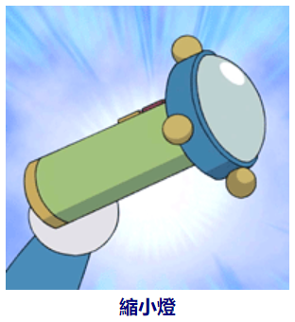 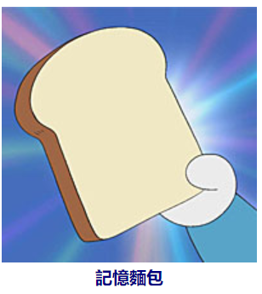



Other Requirements:

* 請先將提供之字串用程式轉為陣列：0.5
  + "任意門 時光機 竹蜻蜓 時光布 記憶麵包 縮小燈 翻譯蒟蒻 如果電話亭 穿透環 更衣照相機"
* 請將圖片調整成30%螢幕大小。0.5
* 請將顯示文字之<p>或<div>之寬度設定成跟圖片同寬，並將文字置中。 0.5
* 文字的參考設定：20px、bold、navy color。1(0.5)
* 字型的參考設定：Helvetica, "Microsoft YaHei", "LiHei Pro", TW-Kai 0.5

Hint:

* 需運用setInterval() 1
* Video 1

1. Please develop a webpage to let users put up the pictures of Doraemon accessories (the same as the previous exercise) to the blackboard.
   * The initial UI is shown as follows: (Please refer to ex-8-2-basic.html)

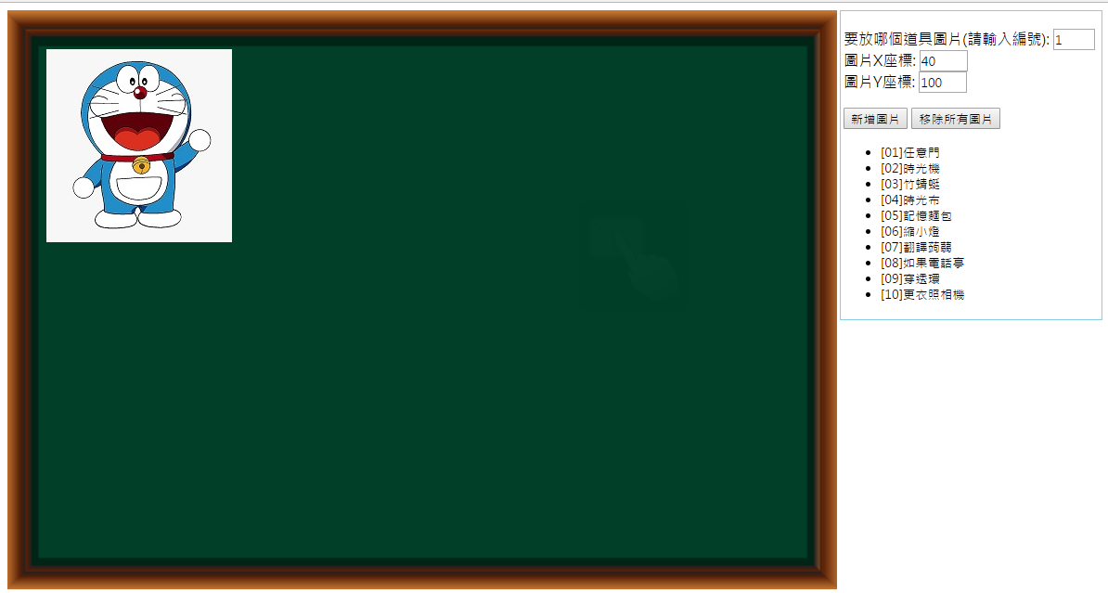

* + The user can select the picture number, input the coordinate of X and Y, and click the button "新增圖片". A corresponding picture will appear in the blackboard. **Newly-added picture should be displayed in front of old picture. 新增1 座標0.5 覆蓋0.5**

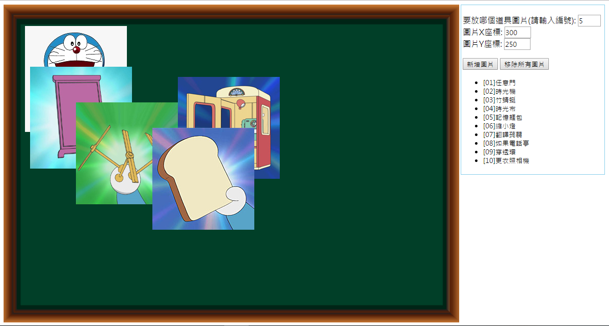

* + When the user clicks the button "移除所有圖片", all pictures should be removed. 0.5
  + When the user closes the *browser* and reopens the browser, **all posted pictures are still shown in the blackboard**. 1

Bonus:

* + The picture can be **dragged and dropped within the scope the blackborad**. The new coordinate will be updated to the local storage. 1(拖曳中心)
  + 圖層不變0.5

Hints:

* + 本題提供HTML與CSS檔內容，但可依個人偏好修改。
  + 請務必先理解目前HTML與CSS之寫法，再下手寫JavaScript。
  + 新增與移除DOM node之方法可參考課本範例12_03。
  + 目前已設定"position: absolute"，可再用top與left屬性來設定位置。
  + 請運用圖層屬性z-index，讓後來加入的圖片顯示於上方。
  + 請參考課本範例11_17瞭解如何使用web storage，但要特別設計key和value之資料格式。
  + Drag and drop之作法可參考<https://www.w3schools.com/html/html5_draganddrop.asp>
  + Drag and drop之處理上，拖拉點約略可當作是圖片之中心點，但放置圖片之座標是圖片之左上角，請思考如何處理此兩座標之轉換。